A10 - Reliability and Safety Analysis

Year: 2023 Semester: Fall Team: 8 Project: Smart Seating System

Creation Date: 11/4/2023 Last Modified: 11/4/2023

Author: Roshan Sundar Email: rmsundar@purdue.edu

Assignment Evaluation: See the Rubric in the Brightspace Assignment

1. Reliability Analysis

**The failure per 10^6 hours (𝝀𝑷) and mean time to failure (MTTF) were calculated through the model failure rate formula: 𝝀𝑷 = (C1 · πt + C2· πe) · πl · πq found in MIL-HDBK-217F [5].**

**MTTF = 10^6 / (24 * 365 * 𝝀𝑷 ) years**

The Coulomb Counter, known as the LTC4150CMS#PBF plays a role in monitoring battery charging and discharging. Since it operates at voltage levels it faces potential challenges related to stress factors. If this component malfunctions it can lead to inaccuracies in battery data potentially harming the battery or causing data loss. This can significantly impact the performance of the system.

Using data in the **MIL-HDBK-217F** regarding PMIC’s, the calculated parameters are listed below. We can see that the part has a high MTTF value, placing it as a very reliable component.

| Parameter name | Description | Value | *Comments regarding choice of parameter value, especially if you had to make assumptions.* |
| --- | --- | --- | --- |
| C1 | Die Complexity | .14 | Power Management IC |
| πT | Temperature coeff. | .5 | Assuming Max 70 C |
| C2 | Package Failure Rate | .002 | SMD/SMT |
| πE | Environment Factor | 4.0 | Assuming GM conditions |
| πQ | Quality Factor | 10 | Commercial Part |
| πL | Learning Factor | 1 | More than 2 years in production |
| Entire design: |  |  |  |
| **𝝀𝑷** |  | .78 |  |
| **MTTF** |  | 1463.7 years | A long time for failure |

The Buck Booster, identified as LTC3531ES6 3.3#TRPBF serves as a voltage regulator that adapts to varying conditions. Operating at levels it is susceptible to issues like temperature buildup and voltage fluctuations. Component failure can result in overheating stress from loads or sudden voltage spikes. These problems can affect the power supply and cause system instability.

Here are the parameters as calculated:

It is shown that the buck booster is also a pretty reliable part, with a MTTF of 677 years.

| Parameter name | Description | Value | *Comments regarding choice of parameter value, especially if you had to make assumptions.* |
| --- | --- | --- | --- |
| C1 | Die Complexity | .14 | PMIC |
| πT | Temperature coeff. | .98 | Assuming worst case 85C |
| C2 | Package Failure Rate | .0078 | 6 Pin SMT |
| πE | Environment Factor | 4.0 | Assuming GM conditions |
| πQ | Quality Factor | 10 | Commercial Part |
| πL | Learning Factor | 1 | More than 2 years in production |
| Entire design: |  |  |  |
| **𝝀𝑷** |  | 1.684 |  |
| **MTTF** |  | 677.92 years | A long time for failure |

The ESP32 microcontroller board known as ESP32-WROOM-32 is the hub of the system due to its complexity and numerous I/O pins. Although it doesn't generate much heat itself, its intricate nature and multiple I/O pins introduce challenges such as electrical stress and risks of electrostatic discharge. A malfunction in this microcontroller can disrupt system functions including communication and control; hence its reliable operation is crucial for maintaining system stability. Since the ESP32-WROOM-32 is 32 bit the die coefficient is .56. Operating temperature range is up to 85 C, which means the temperature coefficient is .98. To determine C2, the package failure rate, the number of pins was taken into account. Since the MCU has 38 pins total, the package failure rate is .017. The following table shows further calculations and assumptions. The mean time to failure value is very strong so the failure rate for this MCU is not very high.

| Parameter name | Description | Value | *Comments regarding choice of parameter value, especially if you had to make assumptions.* |
| --- | --- | --- | --- |
| C1 | Die Complexity | .56 | 32 bit microcontroller |
| πT | Temperature coeff. | .98 | Assuming Digital MOS |
| C2 | Package Failure Rate | .017 | Non Hermetic Package |
| πE | Environment Factor | 4.0 | Assuming GM conditions |
| πQ | Quality Factor | 10 | Commercial Part |
| πL | Learning Factor | 1 | More than 2 years in production |
| Entire design: |  |  |  |
| **𝝀𝑷** |  | 6.168 |  |
| **MTTF** |  | 185.185 years | A long time for failure |

Summary

Our ESP32-WROOM-32D has the worst reliability out of the three components analyzed. However, since our product isn’t designed to be completely long-lasting, having a MTTF value of 185 years is more than acceptable. Our other two components have even higher reliability scores so there isn’t much to take into matter in that regard. There could be many ways to increase reliability as well such as using military parts, applying heat sinks, pads, or small fans in our system to develop some sort of thermal regulation system. This will drastically help reduce the temperature coefficient which will improve any MTTF scores.

1. Failure Mode, Effects, and Criticality Analysis (FMECA)

See Appendix A and Appendix B for FMCEA.

3.0 Sources Cited:

[1] “ESP32-WROOM-32 Datasheet.” Available: <https://www.espressif.com/sites/default/files/documentation/esp32-wroom-32_datasheet_en.pdf> (accessed Nov. 04, 2023).

[2] “LTC4150 Coulomb Counter/Battery Gas Gauge.” <https://www.analog.com/media/en/technical-documentation/data-sheets/4150fc.pdf> (accessed Nov. 04, 2023).

[3] Analog Devices. "ADXL345 Datasheet." [Online]. Available: <https://www.analog.com/media/en/technical-documentation/data-sheets/3531fb.pdf>. (accessed Nov. 04, 2023).

[4] “USBXpressTM Family CP2102N Data Sheet.” [Online]. Available: <https://www.mouser.com/datasheet/2/368/cp2102n_datasheet-1634912.pdf> (accessed Nov. 04, 2023).

[5] “Military Handbook Reliability Prediction of Electronic Equipment” Department of Defense. Washington DC. MIL-HDBK-217F, Dec. 2, 1991.

Appendix A: Schematic Functional Blocks 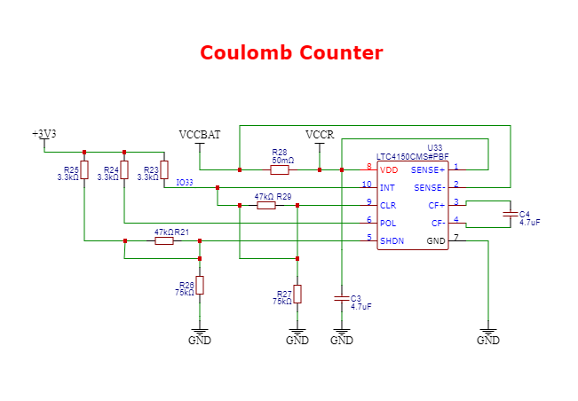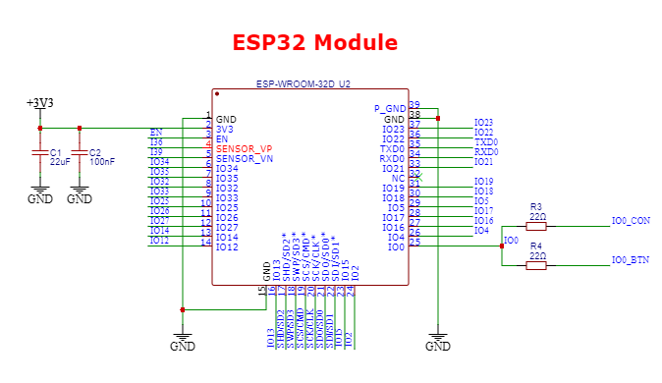

Appendix B: FMECA Worksheet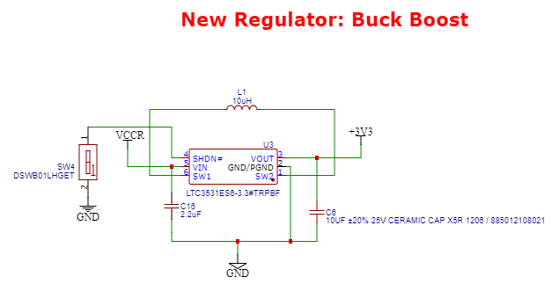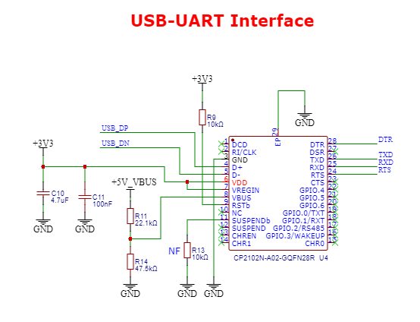

ESP32 MCU

| **Failure No.** | **Failure Mode** | **Possible Causes** | **Failure Effects** | **Method of Detection** | **Criticality** | **Remarks** |
| --- | --- | --- | --- | --- | --- | --- |
| 1 | Noise Error | Mismatched capacitor value C1 & C2. | Might result in insufficient noise filtering and power supply stability. | Verify component code before soldering | Un-Critical  λ > 10^(-6) | Trivial to debug. |
| 2 | Connection Issue | Particularly poor soldering or faulty connections | Can lead to intermittent contact or open circuits, disrupting the functionality of the capacitors. | Uneven solder joints | Un-Critical  λ > 10^(-6) | Good soldering tools prep is recommended, use the smallest soldering tip you could find. |
| 3 | Power Suply Failure | Exceeding the voltage ratings of the capacitors | Can lead to catastrophic failure or damage, posing a risk to the power supply circuit. | Verify component voltage rating before purschase | Un-Critical  λ > 10^(-6) | Ensure we have ordered the correct parts where all the ratings have been verified |
| 4 | Filtering Error | Improper placement, where the capacitors are not positioned as close as possible to the ESP32. | May introduce inductance in long traces, limiting their effectiveness in filtering high-frequency noise. | Visual inspection | Un-Critical  λ > 10^(-6) | Ultimately, the original layout needs to be strictly followed. |

Coulomb Counter

| **Failure No.** | **Failure Mode** | **Possible Causes** | **Failure Effects** | **Method of Detection** | **Criticality** | **Remarks** |
| --- | --- | --- | --- | --- | --- | --- |
| 1 | Persistant Overvoltage | Battery with incorrect specs (>8.5v, >1A) plugged in | Fry LTC4150, no longer able to count coulombs.  Pass over-spec voltage to Buck Boost. | Voltage monitoring.  Software polling. | Critical  λ < 10^(-6) | Should be easy to avoid as long as we are careful about ensuring the right battery is plugged in |
| 2 | Persistant Undervoltage | Battery voltage drains below minimum operating voltage, 2.7v | Unable to count coulombs. | Voltage monitoring.  Software polling. | Un-Critical  λ > 10^(-6) | Software steps can be taken to notify administrator that battery must be changed |
| 3 | Excessive Heat | Poor ventilation and heat dissipation, high ambient temp. | Reduced accuracy, potential component damage. | Temperature monitoring under various operating conditions | Un-Critical  λ > 10^(-6) | Mitigation may be achieved through use of a heat sink. |
| 4 | Damaged Sense Resistor R28 | Excessive heat, high voltage or current pass through resistor | Reduced accuracy, potential open circuit | Voltage and current monitoring. | Un-Critical  λ > 10^(-6) | A resistor with higher temperature, voltage, and current ratings could be used in place, at the cost of higher voltage loss. |

Buck-Boost

| **Failure No.** | **Failure Mode** | **Possible Causes** | **Failure Effects** | **Method of Detection** | **Criticality** | **Remarks** |
| --- | --- | --- | --- | --- | --- | --- |
| 1 | Incorrect Component Selection (Switch) | Incorrect switch component selection | Inadequate voltage regulation and efficiency | Checking difference between input and output of voltage regulator using DMM | Un-Critical  λ > 10^(-6) | Thorough inspection of switch before installation is required. |
| 2 | Voltage Regulator Overheating | Excessive current or thermal stress | Overheating, potential damage to voltage regulator | Monitoring temperature, thermal protection circuit | Un-Critical  λ > 10^(-6) | May requires additional component to handle thermalt. |
| 3 | Connection issues (SW1, Sw2, Vout) | Poor soldering, faulty connections | Intermittent contact, system instability | Observing voltage fluctuations, electrical tests | Critical  λ < 10^(-6) | Cross check multiple documentations and resolder if there’s a slightest uncertainty . |
| 4 | Exceed voltage ratings C6 | Component selection or design error | Capacitor damage, potential power supply hazards | Monitoring voltage, electrical tests | Un-Critical  λ > 10^(-6) | Have additional available component with different ratings for experimentations. |

USB-UART

| **Failure No.** | **Failure Mode** | **Possible Causes** | **Failure Effects** | **Method of Detection** | **Criticality** | **Remarks** |
| --- | --- | --- | --- | --- | --- | --- |
| 1 | Connection issues | Soldering CP2102N, QFN part. | Unable to upload firmware to ESP32, or monitor serial output. | Electrical testing, software monitoring. | Un-Critical  λ > 10^(-6) | Can simply re-solder or flywire as needed, also have a backup header. |
| 2 | Signal Interference | Power lines from Buck Boost, ambient interference from emf. | UART signal degradation, corrupt data transfer. | Serial monitoring, electrical interference testing. | Critical  λ < 10^(-6) | May need to flywire from the backup header to fix this, since the traces cannot be further insulated/fixed. |
| 3 | Power Transients | Intermittent spike in voltage or current demand from sudden high draw. | Potential damage to CP2102N and ESP32, corrupt UART signals. | Voltage, current, and serial monitoring. | Un-Critical  λ > 10^(-6) | Device has low current and voltage draw. USB is only used for short durations when programming. |
| 4 | Driver/Compatibility issues | Using chip that is out of date or no-longer has supported drivers | May be unable to communicate with ESP32 | Serial monitoring. | Un-Critical  λ > 10^(-6) | The CP2102N should still have driver support, we also have a serial backup that should allow a chip that is supported to still interface with the ESP32. |